Synopsis

Project Title-
Employee Salary Prediction Using Regression Based Machine Learning

Problem Id: 03

Student Name-Ansh Gupta (Leader)
University Roll number-2028391
Section-L

Student Name-Agamya Saini
University Roll number-2028385
Section-L

Student Name-Amritaanshu Dheeman
University Roll number-2028390
Section-L

- Problem Description:

In today’s organizations, deciding an employee’s salary is not simple, as it depends on many factors like experience, education, job role, performance, and skills. Usually, salary decisions are made manually, which can sometimes be unfair or inconsistent. Because of this, there is a need for a system that can predict salary in a more accurate and unbiased way.

In this project, we aim to build a machine learning model that can predict employee salary based on different features. Since real company data is not easily available, we created a synthetic dataset with 20 features that represent a real working environment.

We also perform data analysis, preprocessing, and feature selection to improve the model’s performance. Different regression models are used and compared to find the best one. This project helps in understanding how different factors affect salary and provides a better approach for decision-making in organizations.

- Steps of Implementation:
The project follows a structured machine learning pipeline consisting of the following phases:
- Data Collection / Generation-
A synthetic dataset is generated using Python to simulate real-world employee data. It contains 20 features including numerical and categorical variables. The data is designed to reflect realistic relationships affecting salary.
- Exploratory Data Analysis (EDA)-
EDA is performed to understand the dataset structure and feature distributions. Visualization techniques like histograms and heatmaps are used. This helps in identifying patterns and relationships with salary.
- Data Preprocessing-
Data is cleaned and prepared for model training. Categorical features are encoded into numerical form and numerical data is scaled. This ensures consistency and improves model performance.
- Feature Selection-
Forward feature selection is applied to select the most relevant features. Features are added step-by-step based on their impact on model accuracy. This reduces complexity and improves efficiency.
- Model Development-
Regression models such as Linear Regression, Ridge Regression, and Lasso Regression are implemented. These models learn the relationship between features and salary. Regularization techniques help prevent overfitting.
- Model Evaluation-
Models are evaluated using R² score and RMSE. R² indicates how well the model fits the data, while RMSE measures prediction error. The best-performing model is selected based on these metrics.
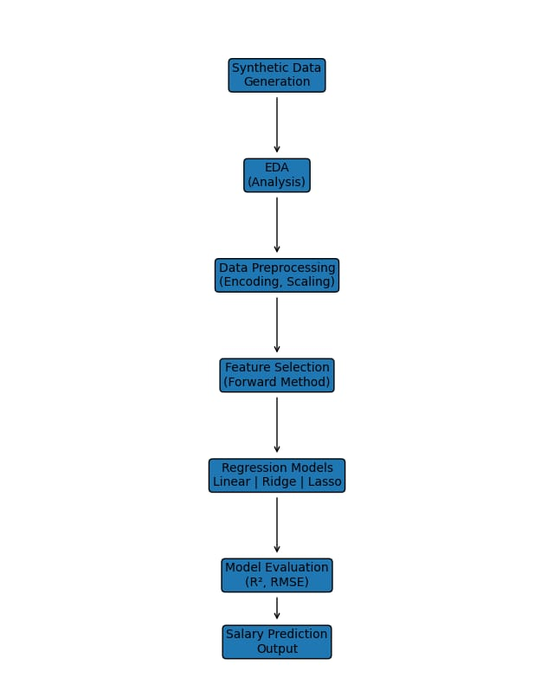
Fig. 1 Architecture Diagram
- Expected Modules/ Libraries to be used :

- NumPy:
Used for numerical computations, data generation, handling arrays efficiently and for mathematical operations.
- Pandas:
Used for data manipulation, dataset handling and also helps in reading, writing and cleaning data easily.
- Matplotlib:
Used for plotting graphs like line plots, histograms and scatter plots.
- Seaborn:
Used for advanced data visualization and provides better looking graphs like heatmaps and pair plots.

- Scikit-learn(sklearn):
Used for preprocessing, feature selection, model building, and evaluation.

- Expected Evaluation metrics and Plots to be used:
To evaluate the performance of the regression models, the following metrics will be used:
- R² Score-
R² score measures how well the model explains the variance in the salary data. Its value ranges from 0 to 1, where a higher value indicates better model performance.
- RMSE (Root Mean Squared Error)-
RMSE measures the average difference between predicted and actual salary values. It penalizes larger errors more strongly, making it useful for evaluating model accuracy.
- MAE (Mean Absolute Error)-
MAE calculates the average absolute difference between predicted and actual values. It is easy to interpret and less sensitive to outliers compared to RMSE.

Visualization Plots-
Histogram-
Used to analyze the distribution of individual features such as age, experience, and salary.
Scatter Plot-
Helps in understanding the relationship between two variables, such as salary vs experience.
Heatmap-
Used to visualize correlations between all features and identify important variables affecting salary.

- Required topics from the subject:

- Strings-
Used for handling categorical data like job role and department. They help in storing and processing text values. Also useful during data cleaning and encoding.
- Files-
Used to read and write datasets in CSV format. Helps in storing and accessing data easily. Important for loading and saving data in the project.

- Functions-
Used to organize the code into smaller parts. They improve readability and reusability. Also help in reducing repetition in the program.

- Libraries-
Provide tools for data analysis and machine learning. They simplify tasks like preprocessing and model building. Help in faster and efficient development.

- Platform Required:

Jupyter Notebook-Used for writing and running code, data analysis, and visualization.
Python (IDLE / VS Code)-Used for implementing machine learning models and project development.
GitHub-Used for version control, project management, and collaboration among team members.
- Books and Link Sources:

- Python for Data Analysis – Wes McKinney
- Hands-On Machine Learning with Scikit-Learn, Keras, and TensorFlow – Aurélien Géron
- https://scikit-learn.org⁠ - for official documentation of machine learning models and preprocessing.
- https://www.kaggle.com⁠ - for dataset and practice.
- https://pandas.pydata.org⁠ - for official documentation of data analysis and manipulation.

